Day 1
Module 1.1: Training Lab Setup and Class Introduction
- Training Lab Setup

Sign up for an oracle account https://profile.oracle.com/myprofile/account/create-account.jspx

Download Oracle Database 19,3 for Windows x64
https://www.oracle.com/database/technologies/oracle-database-software-downloads.html#license-lightbox

Microsoft Windows 64-bit workstation with 6gb ram or more and an intel i3 equivalent or higher processor

Introduction to PL/SQL
Architecture of PL/SQL
PL/SQL Language Elements
Structure of PL/SQL Block

PL/SQL stands for Procedural Language/Structured Query Language. PL/SQL is an extension of the SQL language. We can say it is the superset of the Structured Query Language specialized for use in the Oracle database. Because it is Procedural language, it eliminates many restrictions of the SQL Language. With the use of SQL, user can only manipulate the information stored into the database. Users can perform very basic operations such as selecting the information from some prefabricated tables, inserting information into those tables, updating the information stored in the table, and also occasionally used to delete information from these tables. PL/SQL extends SQL by adding control structures found in the other procedural languages. Procedural constructs blend seamlessly with Oracle SQL, resulting in a structured, powerful language. PL/SQL combines the SQL’s language’s ease of data manipulation and the procedural language’s ease of programming.

1.2 SQL Vs PL/SQL
Some of the differences between SQL and PL/SQL are highlighted and shown below:

SQL does not have any procedural capabilities. By procedural capabilities here we mean that there is no provision of conditional checking, looping and branching, which are very essential for filtration of data before entering it into the database.

ORACLE has provided all procedural capabilities in PL/SQL to support data filtration.

SQL statements are passed to oracle engine (server) one at a time. Therefore each time for each statement a call is made to the server resources and these resources are opened and closed every time. And hence generating network traffic resulting in slow processing.

In PL/SQL it sends the bundle of SQL statements to the oracle server in the form of BLOCK and hence calling the server resources only once for that block even if that block is having more than one SQL statement. After processing all the statements in a block ORACLE server closes the resources results in faster execution of SQL statements in a PL/SQL block.

In SQL there is no provision of handling errors and exceptions, which means that if any SQL statement fails to execute, then oracle gives its own error messages and error code which may not be user friendly.

Where as in PL/SQL we can program the block of statements to handle the errors in such a way that if any of the statements fails to execute then we can display user-friendly appropriate messages.

SQL does not support PL/SQL statements

PL/SQL supports SQL statements in its block.

We cannot store the intermediate results of a query in variables in SQL.

PL/SQL supports declaring the variables so as to store intermediate results of a query for later use. These variables can be used anywhere in any other SQL statement of same PL/SQL block.

1.3 Advantages of PL/SQL
PL/SQL is a completely portable, high-performance transaction processing language, which offers the following advantages:

Supports the declaration and manipulation of object types and collections.

Allows the calling of external functions and procedures.

Contains new libraries of built-in packages. A package is a file that group functions, cursors, stored procedures, and variables in one place.

Triggers: A trigger is a PL/SQL program that is stored in the database and executed immediately before or after the INSERT, UPDATE, and DELETE commands.

Cursors: Oracle uses workspaces to execute the SQL commands. Through PL/SQL cursors, it is possible to name the workspace and access its information.

Support for SQL: PL/SQL allows us to use all the SQL data manipulation commands, transaction control commands, SQL functions (except group functions), operators and pseudo columns, thus allowing us to manipulate data values in a table more flexibly and effectively.

1.4 Architecture of PL/SQL
The PL/SQL engine executes the PL/SQL Blocks. The PL/SQL engine executes only the procedural statements and sends the SQL statements to the SQL statement executor in the Oracle Server. The PL/SQL engine resides in the Oracle Server. The call to the Oracle engine needs to be made only once to execute any number of SQL statements. if these SQL sentences are bundle inside a PL/SQL block. Since the oracle engine is called only once for each block, resulting in increased speed of processing as compared to call for each SQL sentence.

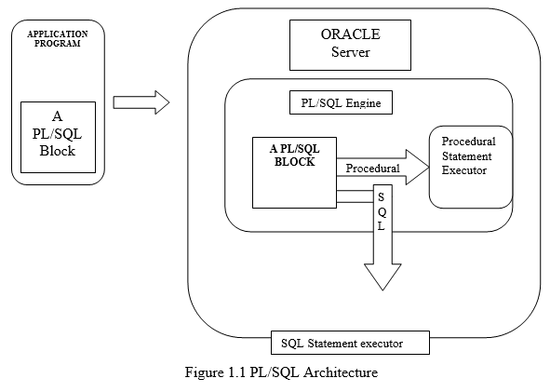

1.5 Structure of PL/SQL Language
PL/SQL is a block-structured language with procedural techniques with features like logic building, looping, error-handling mechanisms, data-types, variables, subroutines, procedural constructs. Block is the smallest piece of PL/SQL code which groups logically related declarations and statements. Declarations are local to the blocks and cease to exist when the block completes.

PL/SQL block consists of three sections:

A PL/SQL statement is terminated with the END statement and a semicolon. Every PL/SQL program must consist of at least one block, which may contain any number of nested sub-blocks. Blocks can be nested in executable and exception-handling parts of a PL/SQL block or subprogram but not in declarative part.

Module 1.2: Basics of Oracle Database

Connecting to a database instance using SQLplus
Connecting to a database instance using SQL Developer
Starting and shutting down database instance
Using Oracle Live SQL

- System requirements for Oracle database 19c for windows
Server hardware requirements
- Processor: AMD64 or Intel EM64T;
- Physical RAM: 2 GB minimum;
- Swap (virtual memory): at least the same size as the physical memory (2 GB minimum);
- Available disk space: 12 GB (OS excluded);
- Video adapter: 256 colors;
- Display (screen resolution): 1024 x 768 minimum.

Hard disk requirements
- Oracle strongly recommends that you install the Oracle database home (Oracle database binaries, trace files, and so on) on Oracle ACFS or NTFS.
- For a single database instance installation, you will need around 12 GB of disk space. This space includes :
  - temp space: 595 MB ;
  - Oracle inventory: 53 MB ;
  - Oracle home: 6.5 GB ;
  - data files (admin, flash_recovery area, oradata, etc.): 4.4 GB.
  - Depending on the installation options selected, this size can be higher.

Supported Windows versions
Oracle Database 19c can be installed on the following Windows x64 distributions:
- Windows Server 2019 x64 – Standard, Datacenter and Essentials;
- Windows Server 2016 x64 – Standard, Datacenter and Essentials and Foundation;
- Windows Server 2012 R2 x64 – Standard, Datacenter and Essentials;
- Windows 10 x64 Pro – Enterprise and Education;
- Windows 8.1 x – Enterprise.

Note: It is highly recommended to update your operating system before starting Oracle Database installation in order to avoid compatibility issues with Oracle 19c and to strengthen the security of the future database.

- download oracle database 19c
- run the setup file
  - select create and configure a single instance
  - select installation type:
    - desktop class (for testing)
    - server class (production, more advanced options)
  - select user (for demo, choose “use virtual account”)
  - configure
    - Oracle base (ex. “c:\oracle19c”)
    - Note Global Database name and Pluggable Database Name
    - Set password

- Start the pluggable databases

Connect to the root database as Admin user
\> sqlplus / as sysdba

Show pluggable databases
sql\> show pdbs
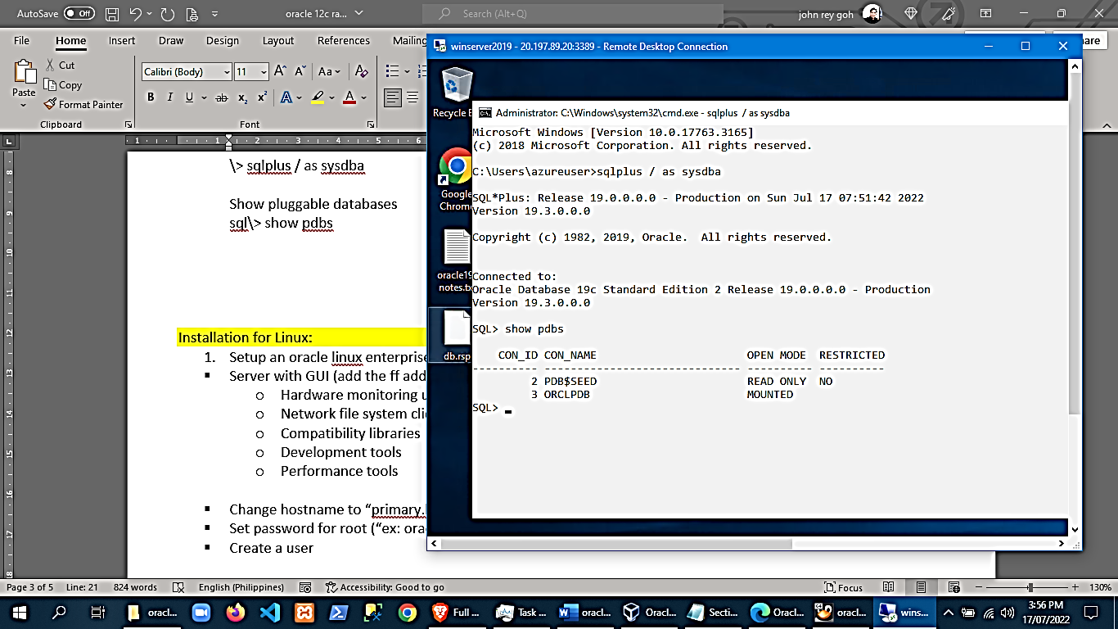

- As shown above, orclpdb (pluggable database is not started). To start it,
sql\> alter pluggable database orclpdb open;
sql\> show pdbs
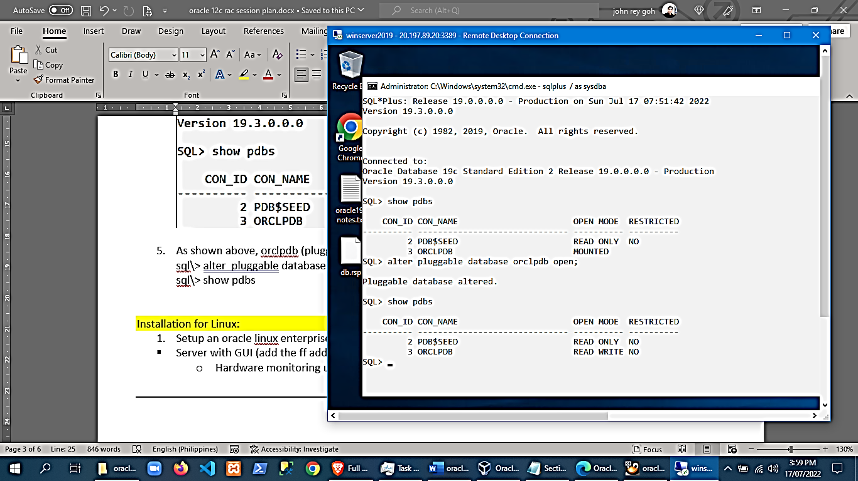

- Automatically start the pluggable database when the container database starts
sql\> alter pluggable database orclpdb save state;

- Shutdown pluggable database
sql\> alter pluggable database orclpdb close;

- Shutdown the database container

safest, longest wait time
sql\> shutdown normal

riskiest, abort tasks
sql\> shutdown abort

force
sql\> shutdown immediate

- Start the database container instance
sql\> startup

- To exit the sql prompt
sql\> exit

Using Oracle SQL Developer (Windows)
- Oracle SQL Developer is no longer included in 19c. You can download and install it.
- You need jdk 8 or 9 or later (18 is not yet supported as of July 17 2022)
To check you installed java version:
\> java –version

- For windows, download oracle sql developer
http://www.oracle.com/technetwork/developer-tools/sql-developer/
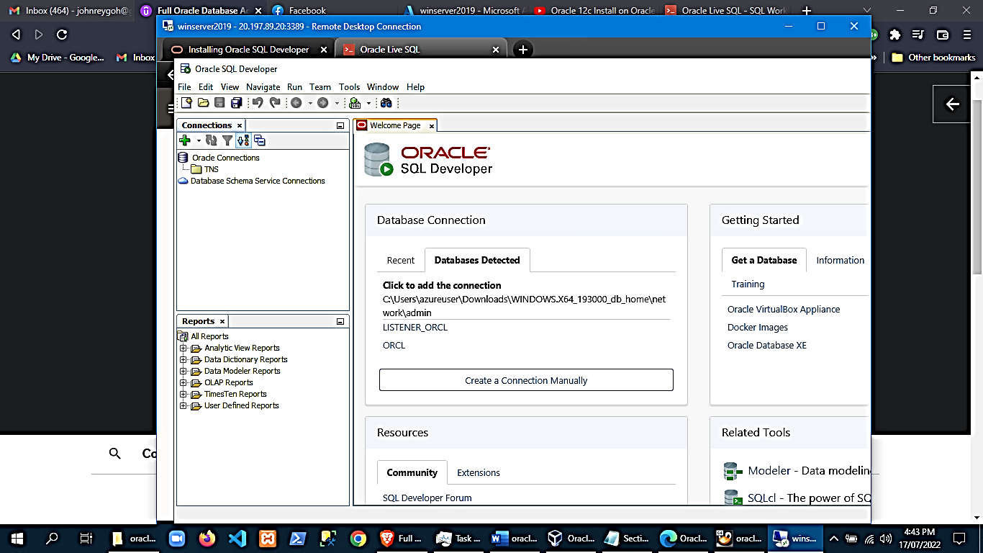

- Change sqldeveloper look and feel to windows:
Sqldevelopertoolspreferenceslook and feel: windows

In learning SQL, aside from using sqldeveloper, you can also use Oracle LiveSQL https://livesql.oracle.com/
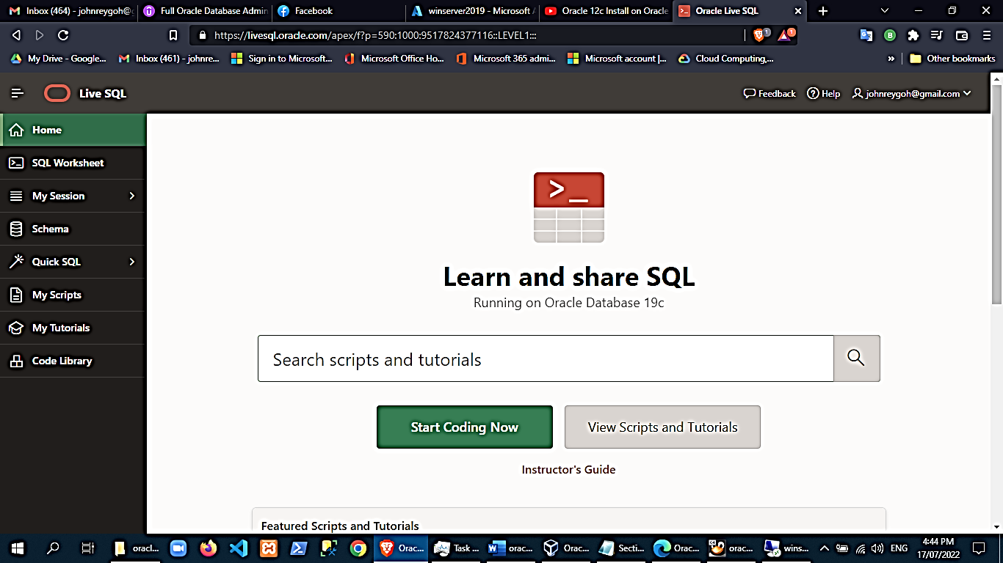

Sample Using LiveSQL:
Sql worksheet
Create table temp1 (id number,column1 varchar2(10))

Insert into temp1(id,column1) values(‘1’,’test’)

Your objects can be accessed in the ‘schema’ menu
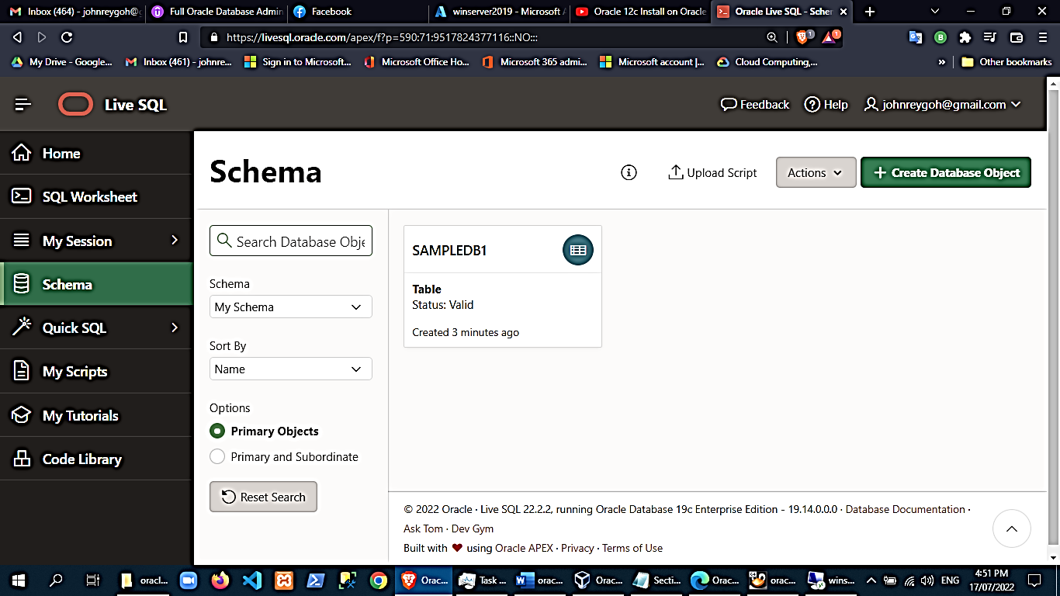

NOTE:
- when you logout of the liveSQL, your objects will be removed!
- You can also save your scripts if you want to.

Module 1.3: Review of SQL statements

Tables

Create table
CREATE TABLE employee
(id int, name varchar(20));

Add column
ALTER TABLE employee
ADD (id int)

Modify column
ALTER TABLE employee
MODIFY( sickHours s float );

Drop column
ALTER TABLE employee
DROP COLUMN vacationPay;

Constraint types and codes
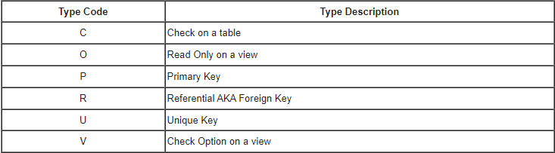

The following statement shows all constraints in the system:
SELECT
table_name,
constraint_name,
constraint_type
FROM user_constraints;

The syntax for creating a unique constraint using a CREATE TABLE statement is:
CREATE TABLE customer
(
id integer not null,
name varchar2(20),
CONSTRAINT customer_id_constraint UNIQUE (id)
);

The syntax for a unique constraint is:
ALTER TABLE employee
ADD CONSTRAINT uniqueEmployeeId UNIQUE(employeeId) USING INDEX ourcompanyIndx_tbs;

The syntax for a foreign constraint is:
ALTER TABLE employee
ADD CONSTRAINT fk_departament FOREIGN KEY (departmentId) REFERENCES departments(Id);

The syntax for dropping (removing) a constraint is:[1]
ALTER TABLE employee
DROP CONSTRAINT uniqueEmployeeId;

CRUD operations

insert using the VALUES keyword
INSERT INTO table_name VALUES ('Value1', 'Value2', ... );
INSERT INTO table_name( Column1, Column2, ... ) VALUES ( 'Value1', 'Value2', ... );

insert using a SELECT statement
INSERT INTO table_name( SELECT Value1, Value2, ... from table_name );
INSERT INTO table_name( Column1, Column2, ... ) ( SELECT Value1, Value2, ... from table_name );

The DELETE statement is used to delete rows in a table.
DELETE FROM table_name WHERE some_column=some_value
DELETE FROM customer WHERE sold = 0;

The UPDATE statement is used to update rows in a table.
UPDATE customer SET state='CA';
UPDATE customer SET name='Joe' WHERE customer_id=10;
UPDATE movies SET invoice='paid' WHERE paid > 0;

The SELECT statement is used to retrieve rows selected from one or more tables, object tables, views, object views, or materialized views.
SELECT *
FROM beverages
WHERE field1 = 'Kona'
AND field2 = 'coffee'
AND field3 = 122;

SELECT INTO
Select into takes the values name, address and phone number out of the table employee, and places them into the variables v_employee_name, v_employee_address, and v_employee_phone_number.

This only works if the query matches a single item. If the query returns no rows it raises the NO_DATA_FOUND built-in exception. If your query returns more than one row, Oracle raises the exception TOO_MANY_ROWS.

SELECT name,address,phone_number
INTO v_employee_name,v_employee_address,v_employee_phone_number
FROM employee
WHERE employee_id = 6;

User Management
Creating a user
CREATE USER brian IDENTIFIED BY brianpass;

The syntax for granting privileges is:
GRANT privilege TO user;

For example:
GRANT dba TO brian;

The syntax for changing user password is:
ALTER USER brian IDENTIFIED BY brianpassword;

Module 2: Using Variables and Constants
Variables in PL/SQL
The Select Into statement
Constants in PL/SQL
Variable Attributes

PL/SQL Scalar Data Types and Subtypes

Numeric
Numeric values on which arithmetic operations are performed.

Character
Alphanumeric values that represent single characters or strings of characters.

Boolean
Logical values on which logical operations are performed.

Datetime
Dates and times.

PL/SQL provides subtypes of data types. For example, the data type NUMBER has a subtype called INTEGER. You can use the subtypes in your PL/SQL program to make the data types compatible with data types in other programs while embedding the PL/SQL code in another program, such as a Java program.

PL/SQL Numeric Data Types and Subtypes

PLS_INTEGER
Signed integer in range -2,147,483,648 through 2,147,483,647, represented in 32 bits

BINARY_INTEGER
Signed integer in range -2,147,483,648 through 2,147,483,647, represented in 32 bits

BINARY_FLOAT
Single-precision IEEE 754-format floating-point number

BINARY_DOUBLE
Double-precision IEEE 754-format floating-point number

NUMBER(prec, scale)
Fixed-point or floating-point number with absolute value in range 1E-130 to (but not including) 1.0E126. A NUMBER variable can also represent 0

DEC(prec, scale)
ANSI specific fixed-point type with maximum precision of 38 decimal digits

DECIMAL(prec, scale)
IBM specific fixed-point type with maximum precision of 38 decimal digits

NUMERIC(pre, secale)
Floating type with maximum precision of 38 decimal digits

DOUBLE PRECISION
ANSI specific floating-point type with maximum precision of 126 binary digits (approximately 38 decimal digits)

FLOAT
ANSI and IBM specific floating-point type with maximum precision of 126 binary digits (approximately 38 decimal digits)

INT
ANSI specific integer type with maximum precision of 38 decimal digits

INTEGER
ANSI and IBM specific integer type with maximum precision of 38 decimal digits

SMALLINT
ANSI and IBM specific integer type with maximum precision of 38 decimal digits

REAL
Floating-point type with maximum precision of 63 binary digits (approximately 18 decimal digits)

Following is a valid declaration −
DECLARE
num1 INTEGER;
num2 REAL;
num3 DOUBLE PRECISION;
BEGIN
null;
END;

When the above code is compiled and executed, it produces the following result −
PL/SQL procedure successfully completed

PL/SQL Character Data Types and Subtypes
CHAR
Fixed-length character string with maximum size of 32,767 bytes

VARCHAR2
Variable-length character string with maximum size of 32,767 bytes

RAW
Variable-length binary or byte string with maximum size of 32,767 bytes, not interpreted by PL/SQL

NCHAR
Fixed-length national character string with maximum size of 32,767 bytes

NVARCHAR2
Variable-length national character string with maximum size of 32,767 bytes

LONG
Variable-length character string with maximum size of 32,760 bytes

LONG RAW
Variable-length binary or byte string with maximum size of 32,760 bytes, not interpreted by PL/SQL

ROWID
Physical row identifier, the address of a row in an ordinary table

UROWID
Universal row identifier (physical, logical, or foreign row identifier)

PL/SQL Boolean Data Types
The BOOLEAN data type stores logical values that are used in logical operations. The logical values are the Boolean values TRUE and FALSE and the value NULL.

However, SQL has no data type equivalent to BOOLEAN. Therefore, Boolean values cannot be used in −
SQL statements
Built-in SQL functions (such as TO_CHAR)
PL/SQL functions invoked from SQL statements
PL/SQL Datetime and Interval Types
The DATE datatype is used to store fixed-length datetimes, which include the time of day in seconds since midnight. Valid dates range from January 1, 4712 BC to December 31, 9999 AD.

The default date format is set by the Oracle initialization parameter NLS_DATE_FORMAT. For example, the default might be 'DD-MON-YY', which includes a two-digit number for the day of the month, an abbreviation of the month name, and the last two digits of the year. For example, 01-OCT-12.

Each DATE includes the century, year, month, day, hour, minute, and second. The following table shows the valid values for each field −

Field Name Valid Datetime Values Valid Interval Values
YEAR -4712 to 9999 (excluding year 0) Any nonzero integer
MONTH 01 to 12 0 to 11
DAY 01 to 31 Any nonzero integer
HOUR 00 to 23 0 to 23
MINUTE 00 to 59 0 to 59
SECOND 00 to 59.9 0 to 59.9(n
TIMEZONE_HOUR -12 to 14 (range accommodates daylight savings time changes) Not applicable
TIMEZONE_MINUTE 00 to 59 Not applicable
TIMEZONE_REGION Found in the dynamic performance view V$TIMEZONE_NAMES Not applicable
TIMEZONE_ABBR Found in the dynamic performance view V$TIMEZONE_NAMES Not applicable

PL/SQL Large Object (LOB) Data Types
Large Object (LOB) data types refer to large data items such as text, graphic images, video clips, and sound waveforms.

LOB data types allow efficient, random, piecewise access to this data. Following are the predefined PL/SQL LOB data types −

Data Type Description Size
BFILE Used to store large binary objects in os files outside the database. System-dependent.
Cannot exceed 4 gigabytes
BLOB Used to store large binary objects in the database. 8 to 128 terabytes (TB)
CLOB Used to store large blocks of character data in the database. 8 to 128 TB
NCLOB Used to store large blocks of NCHAR data in the database. 8 to 128 TB

PL/SQL User-Defined Subtypes
A subtype is a subset of another data type, which is called its base type. A subtype has the same valid operations as its base type, but only a subset of its valid values.

PL/SQL predefines several subtypes in package STANDARD. For example, PL/SQL predefines the subtypes CHARACTER and INTEGER as follows −

SUBTYPE CHARACTER IS CHAR;
SUBTYPE INTEGER IS NUMBER(38,0);

You can define and use your own subtypes. The following program illustrates defining and using a user-defined subtype
DECLARE
SUBTYPE name IS char(20);
SUBTYPE message IS varchar2(100);
salutation name;
greetings message;
BEGIN
salutation := 'Reader ';
greetings := 'Welcome to the World of PL/SQL';
dbms_output.put_line('Hello ' || salutation || greetings);
END;

When the above code is executed at the SQL prompt, it produces the following result −
Hello Reader Welcome to the World of PL/SQL
PL/SQL procedure successfully completed.

The syntax for declaring a variable is −
variable_name [CONSTANT] datatype [NOT NULL] [:= | DEFAULT initial_value]

Where, variable_name is a valid identifier in PL/SQL, datatype must be a valid PL/SQL data type or any user defined data type which we already have discussed in the last chapter. Some valid variable declarations along with their definition are shown below −
sales number(10, 2);
pi CONSTANT double precision := 3.1415;
name varchar2(25);
address varchar2(100);

When you provide a size, scale or precision limit with the data type, it is called a constrained declaration. Constrained declarations require less memory than unconstrained declarations. For example −
sales number(10, 2);
name varchar2(25);
address varchar2(100);

Initializing Variables in PL/SQL
Whenever you declare a variable, PL/SQL assigns it a default value of NULL. If you want to initialize a variable with a value other than the NULL value, you can do so during the declaration, using either of the following −

The DEFAULT keyword
The assignment operator

For example −
counter binary_integer := 0;
greetings varchar2(20) DEFAULT 'Have a Good Day';

You can also specify that a variable should not have a NULL value using the NOT NULL constraint. If you use the NOT NULL constraint, you must explicitly assign an initial value for that variable.

It is a good programming practice to initialize variables properly otherwise, sometimes programs would produce unexpected results. Try the following example which makes use of various types of variables −

DECLARE
a integer := 10;
b integer := 20;
c integer;
f real;
BEGIN
c := a + b;
dbms_output.put_line('Value of c: ' || c);
f := 70.0/3.0;
dbms_output.put_line('Value of f: ' || f);
END;
/

When the above code is executed, it produces the following result −
Value of c: 30
Value of f: 23.333333333333333333

PL/SQL procedure successfully completed.

Variable Scope in PL/SQL
PL/SQL allows the nesting of blocks, i.e., each program block may contain another inner block. If a variable is declared within an inner block, it is not accessible to the outer block. However, if a variable is declared and accessible to an outer block, it is also accessible to all nested inner blocks. There are two types of variable scope −

- Local variables − Variables declared in an inner block and not accessible to outer blocks.
- Global variables − Variables declared in the outermost block or a package.
- Following example shows the usage of Local and Global variables in its simple form −

DECLARE
-- Global variables
num1 number := 95;
num2 number := 85;
BEGIN
dbms_output.put_line('Outer Variable num1: ' || num1);
dbms_output.put_line('Outer Variable num2: ' || num2);
DECLARE
-- Local variables
num1 number := 195;
num2 number := 185;
BEGIN
dbms_output.put_line('Inner Variable num1: ' || num1);
dbms_output.put_line('Inner Variable num2: ' || num2);
END;
END;
/

When the above code is executed, it produces the following result −
Outer Variable num1: 95
Outer Variable num2: 85
Inner Variable num1: 195
Inner Variable num2: 185

PL/SQL procedure successfully completed.

Assigning SQL Query Results to PL/SQL Variables

You can use the SELECT INTO statement of SQL to assign values to PL/SQL variables. For each item in the SELECT list, there must be a corresponding, type-compatible variable in the INTO list. The following example illustrates the concept.
Let us create a table named CUSTOMERS −

CREATE TABLE CUSTOMERS(
ID INT NOT NULL,
NAME VARCHAR (20) NOT NULL,
AGE INT NOT NULL,
ADDRESS CHAR (25),
SALARY DECIMAL (18, 2),
PRIMARY KEY (ID)
);

Let us now insert some values in the table −

INSERT INTO CUSTOMERS (ID,NAME,AGE,ADDRESS,SALARY)
VALUES (1, 'Ramesh', 32, 'Ahmedabad', 2000.00 );

INSERT INTO CUSTOMERS (ID,NAME,AGE,ADDRESS,SALARY)
VALUES (2, 'Khilan', 25, 'Delhi', 1500.00 );

INSERT INTO CUSTOMERS (ID,NAME,AGE,ADDRESS,SALARY)
VALUES (3, 'kaushik', 23, 'Kota', 2000.00 );

INSERT INTO CUSTOMERS (ID,NAME,AGE,ADDRESS,SALARY)
VALUES (4, 'Chaitali', 25, 'Mumbai', 6500.00 );

INSERT INTO CUSTOMERS (ID,NAME,AGE,ADDRESS,SALARY)
VALUES (5, 'Hardik', 27, 'Bhopal', 8500.00 );

INSERT INTO CUSTOMERS (ID,NAME,AGE,ADDRESS,SALARY)
VALUES (6, 'Komal', 22, 'MP', 4500.00 );

The following program assigns values from the above table to PL/SQL variables using the SELECT INTO clause of SQL −
DECLARE
c_id customers.id%type := 1;
c_name customers.name%type;
c_addr customers.address%type;
c_sal customers.salary%type;
BEGIN
SELECT name, address, salary INTO c_name, c_addr, c_sal
FROM customers
WHERE id = c_id;
dbms_output.put_line
('Customer ' ||c_name || ' from ' || c_addr || ' earns ' || c_sal);
END;
/

When the above code is executed, it produces the following result −
Customer Ramesh from Ahmedabad earns 2000
PL/SQL procedure completed successfully

